Week 5 ADF 2

Copy-activity and linking-ADF-databricks

Databricks access tocken

NOTE:

* source = source
* Sink = destination (where you want make a copy of your data)

Inside my adls:

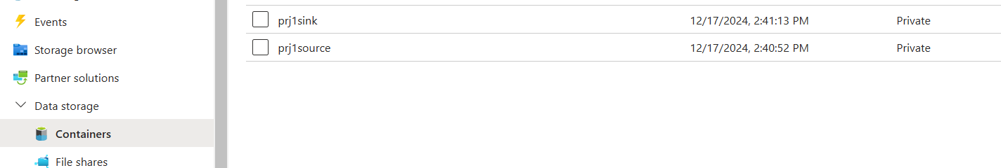

Inside prj1source

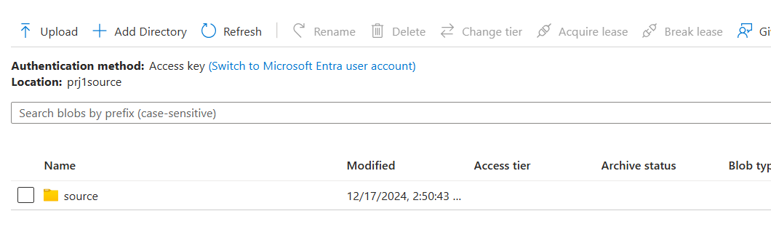

Prj1source >> source >> our data file

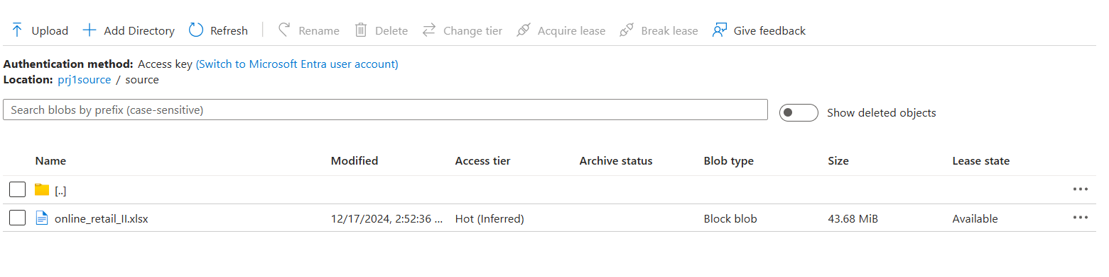

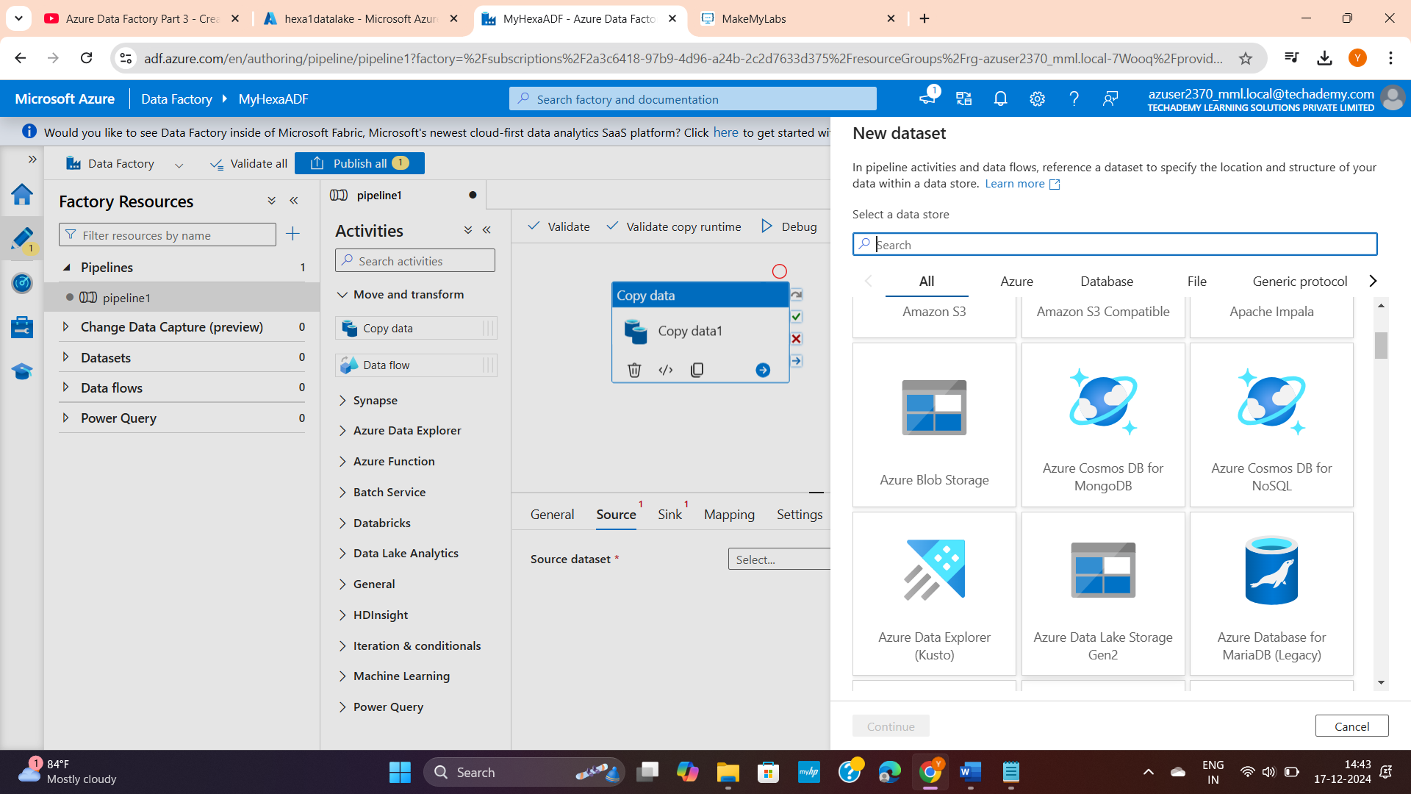

Click Source1 and add a file and click Sink and file

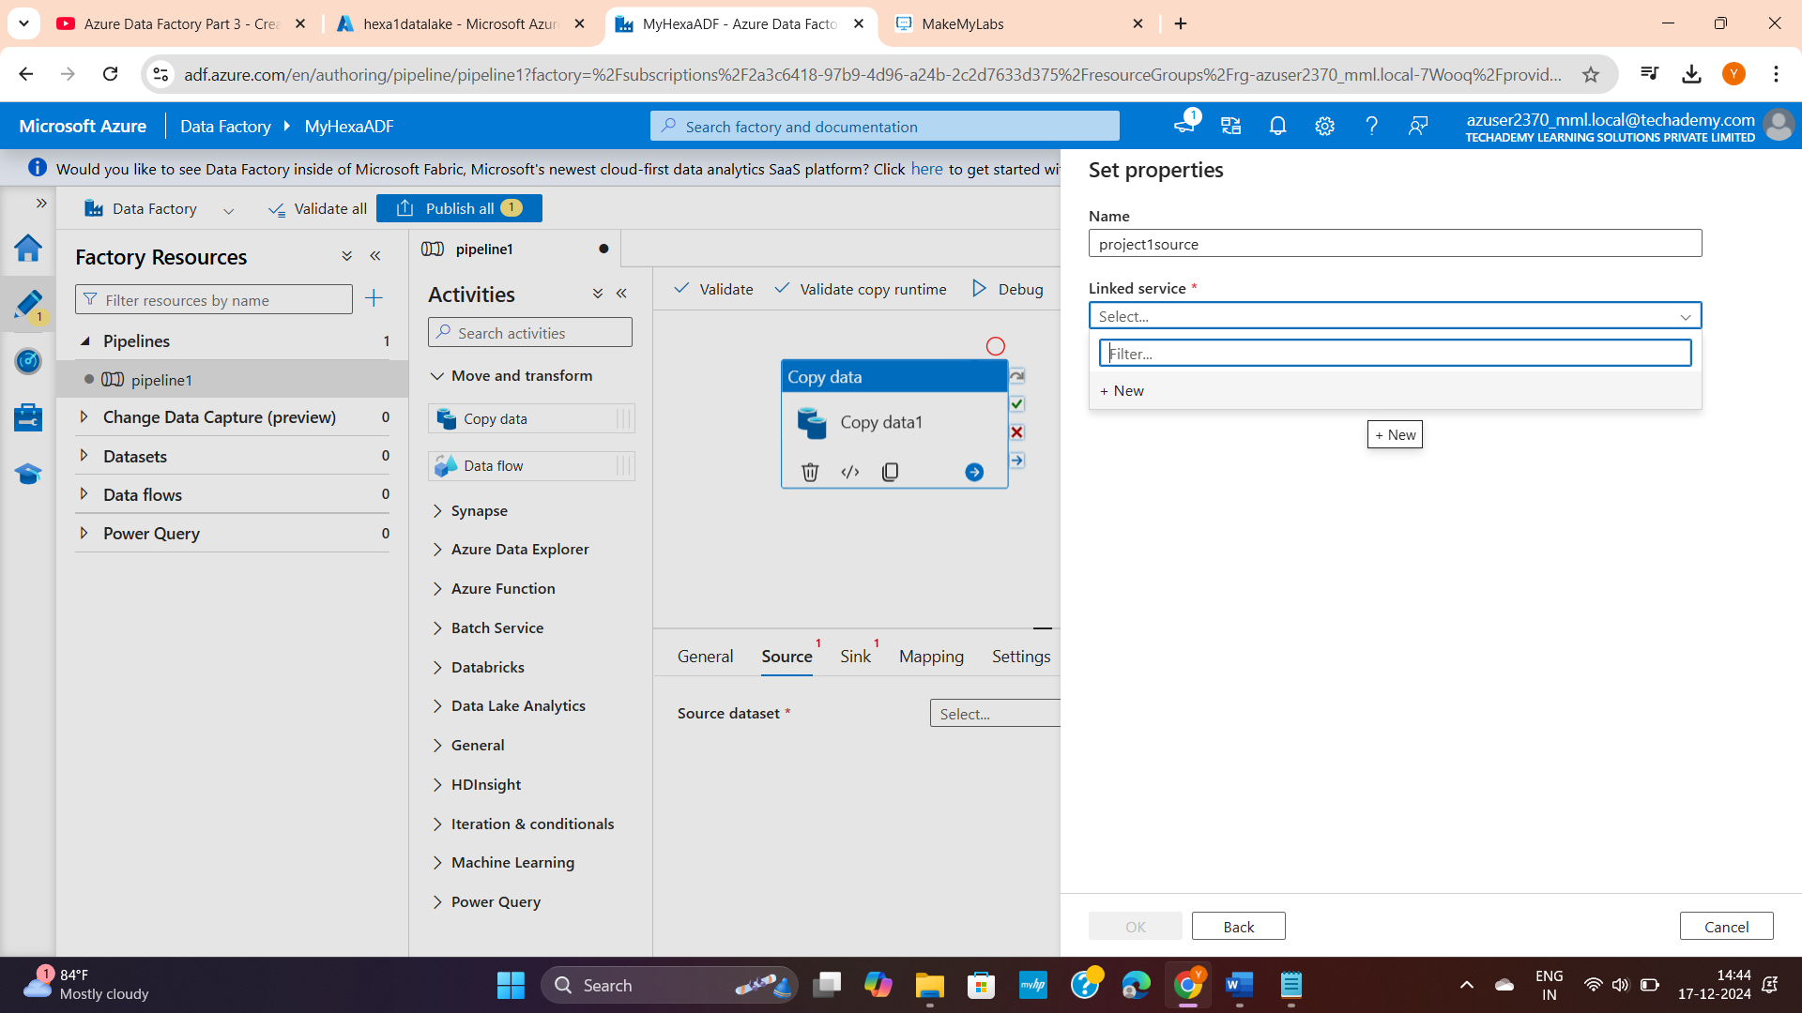

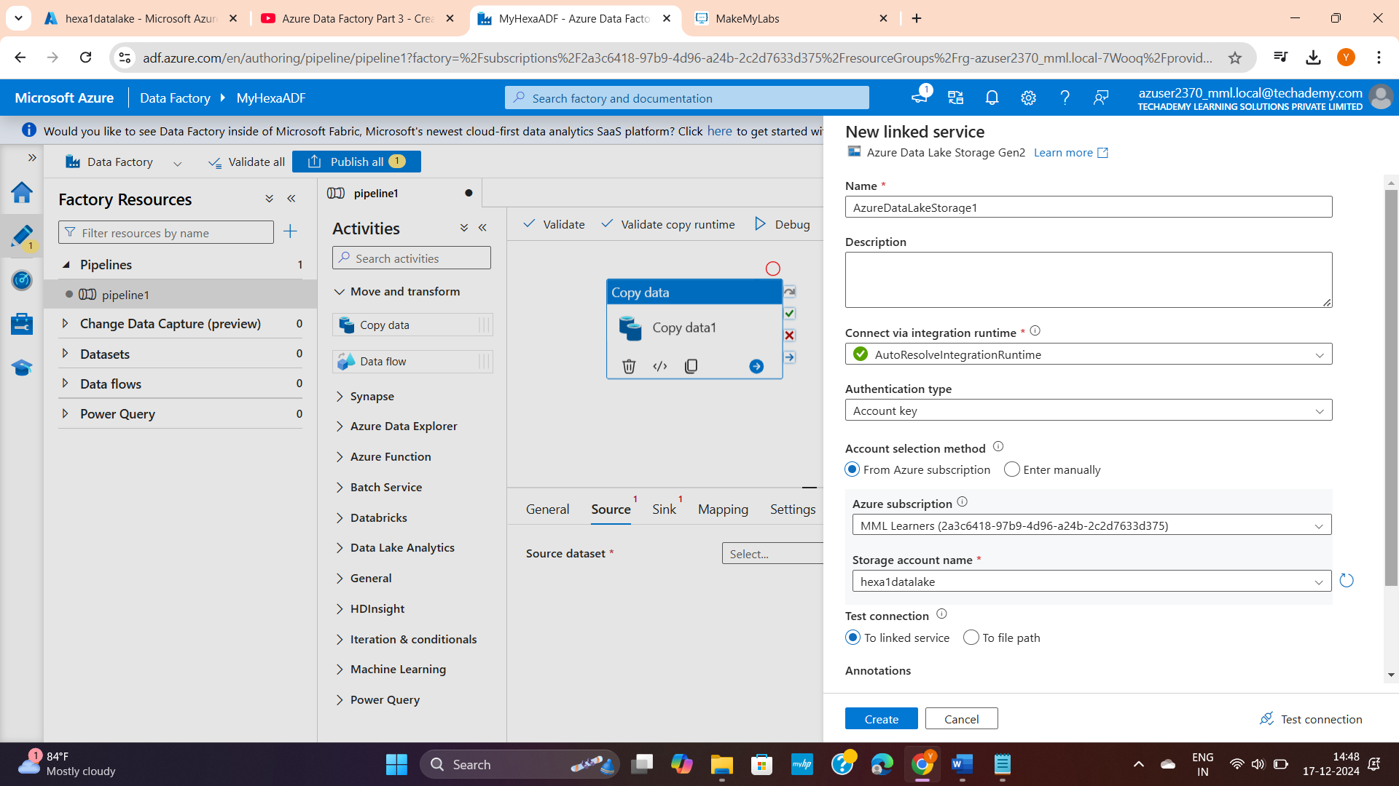

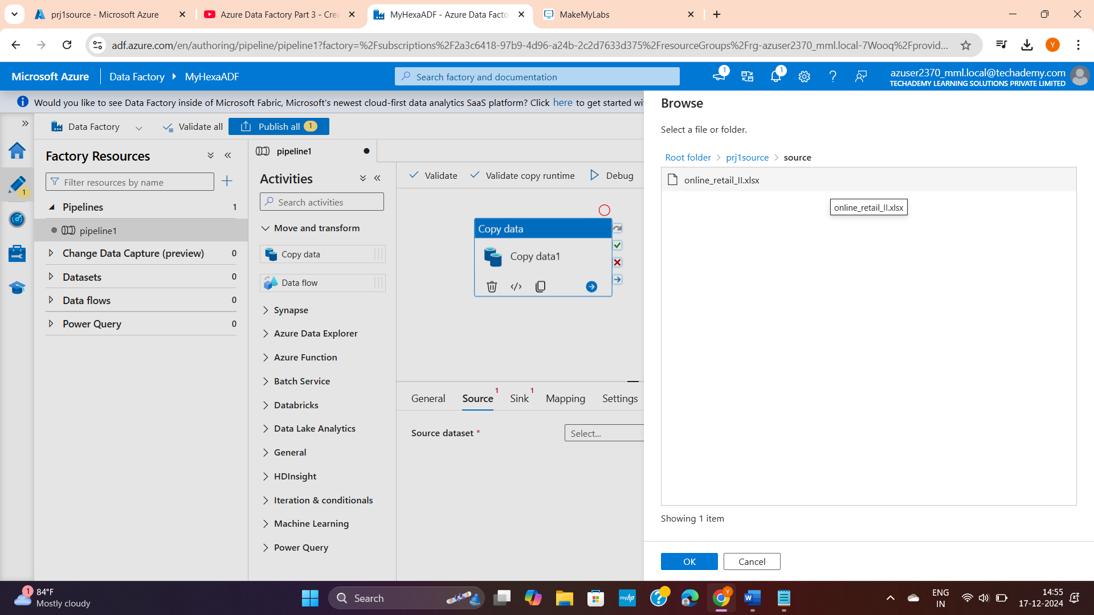

Now click sink1 and add a file path process

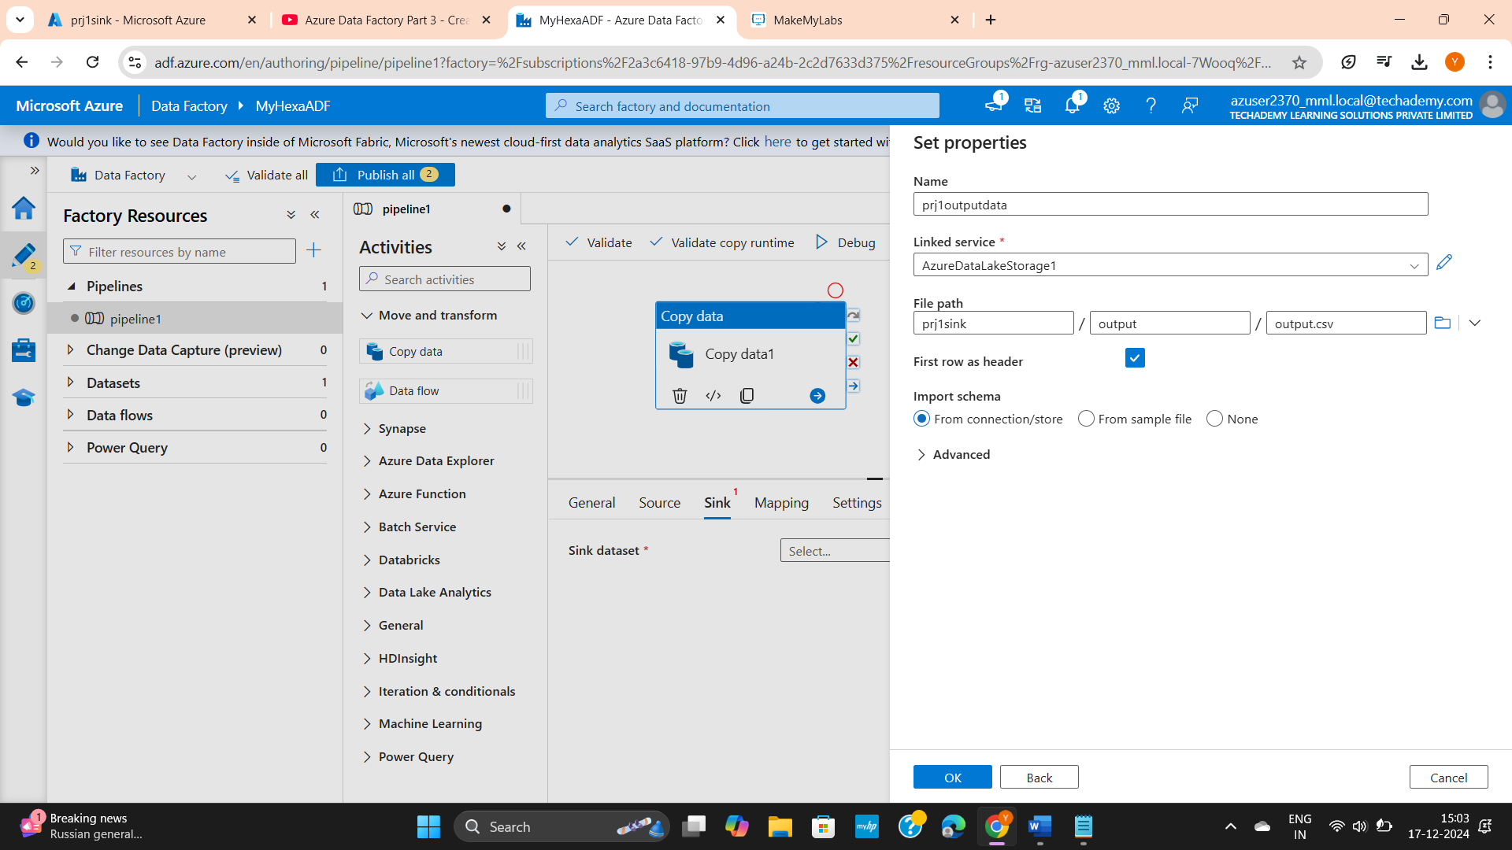

Here I am copying a data from a container in adls to another container in adls. Similarly you can cop data from adls to azure databricks as below:

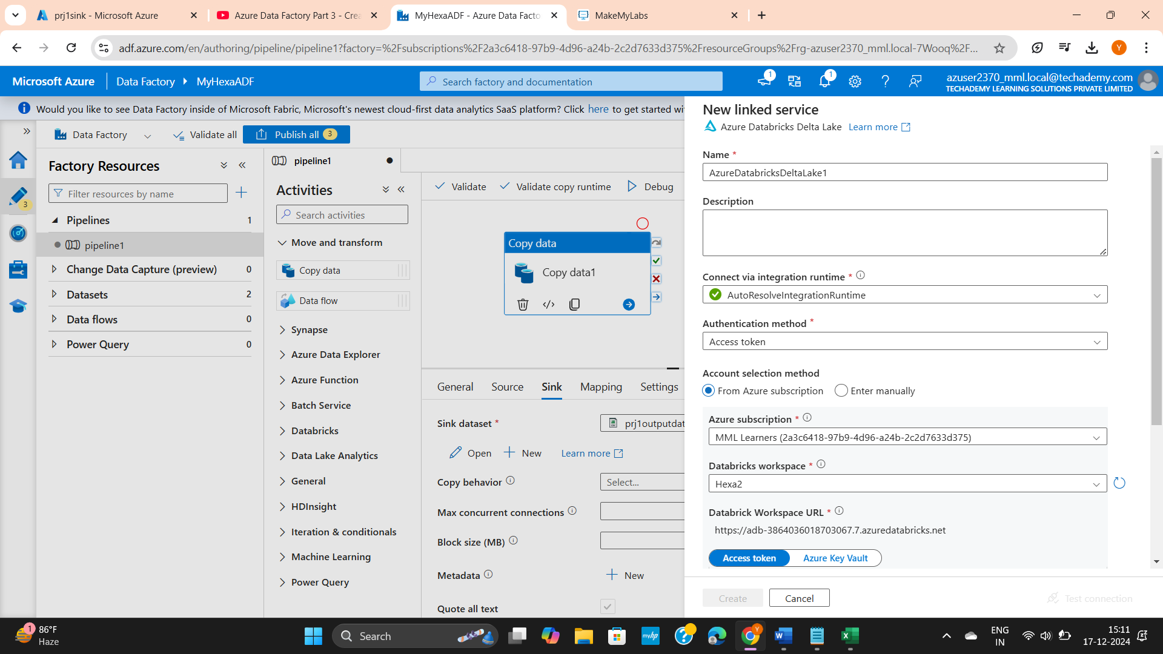

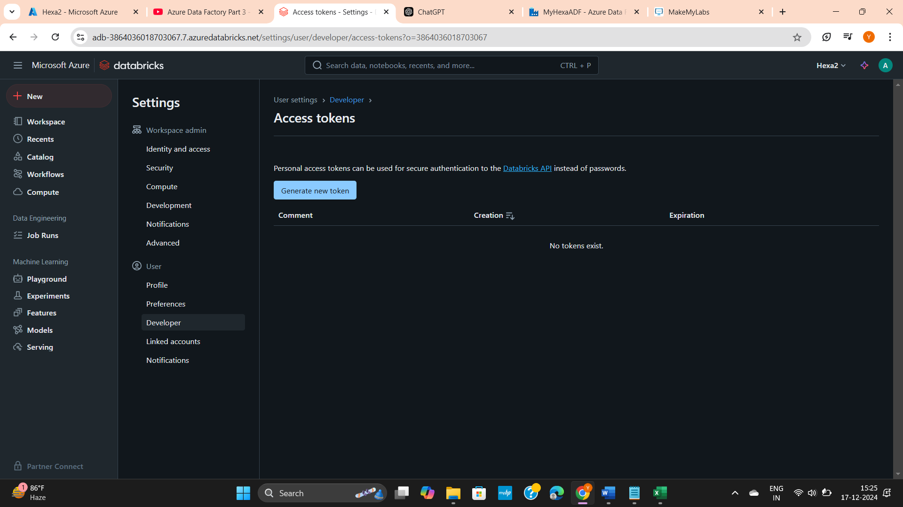

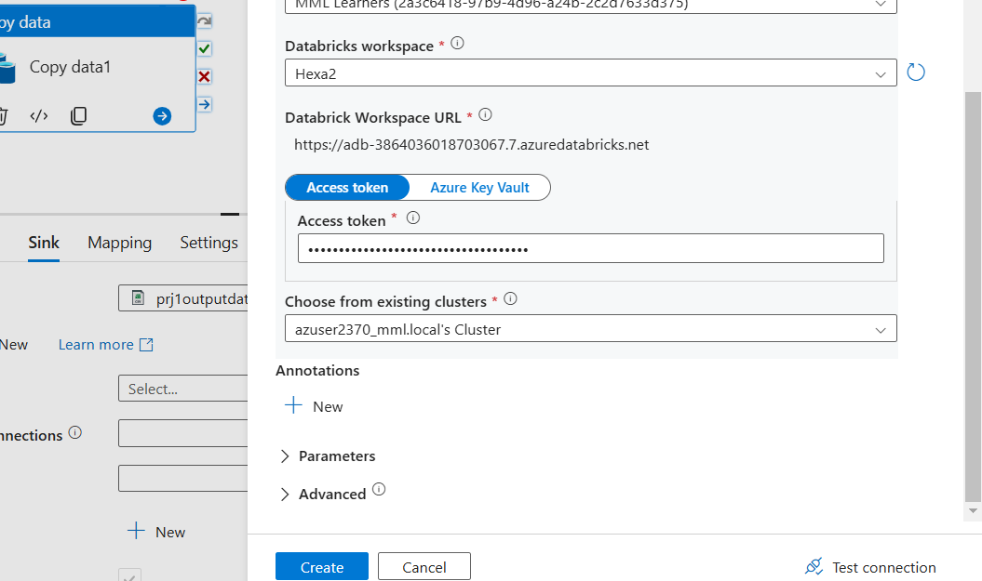

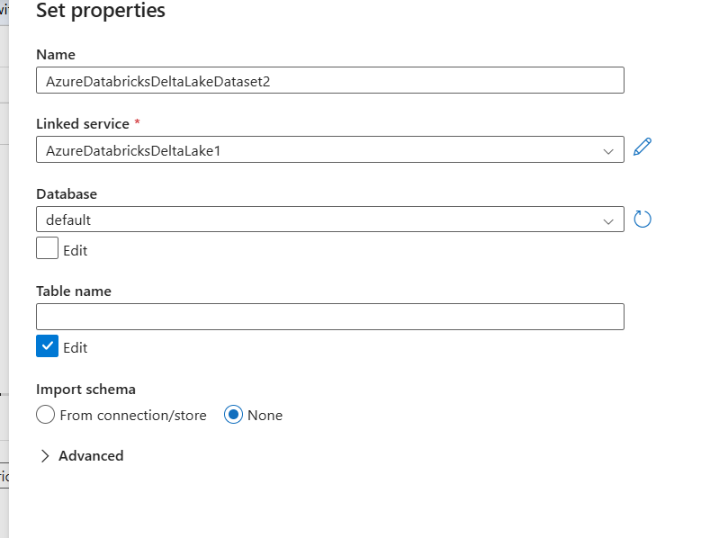

Continuation in DE prj 1 reference file